Approach – 1 Full LLM Extraction

Basic OCR Extraction of text and passing it to an LLM to extract values and format the output.
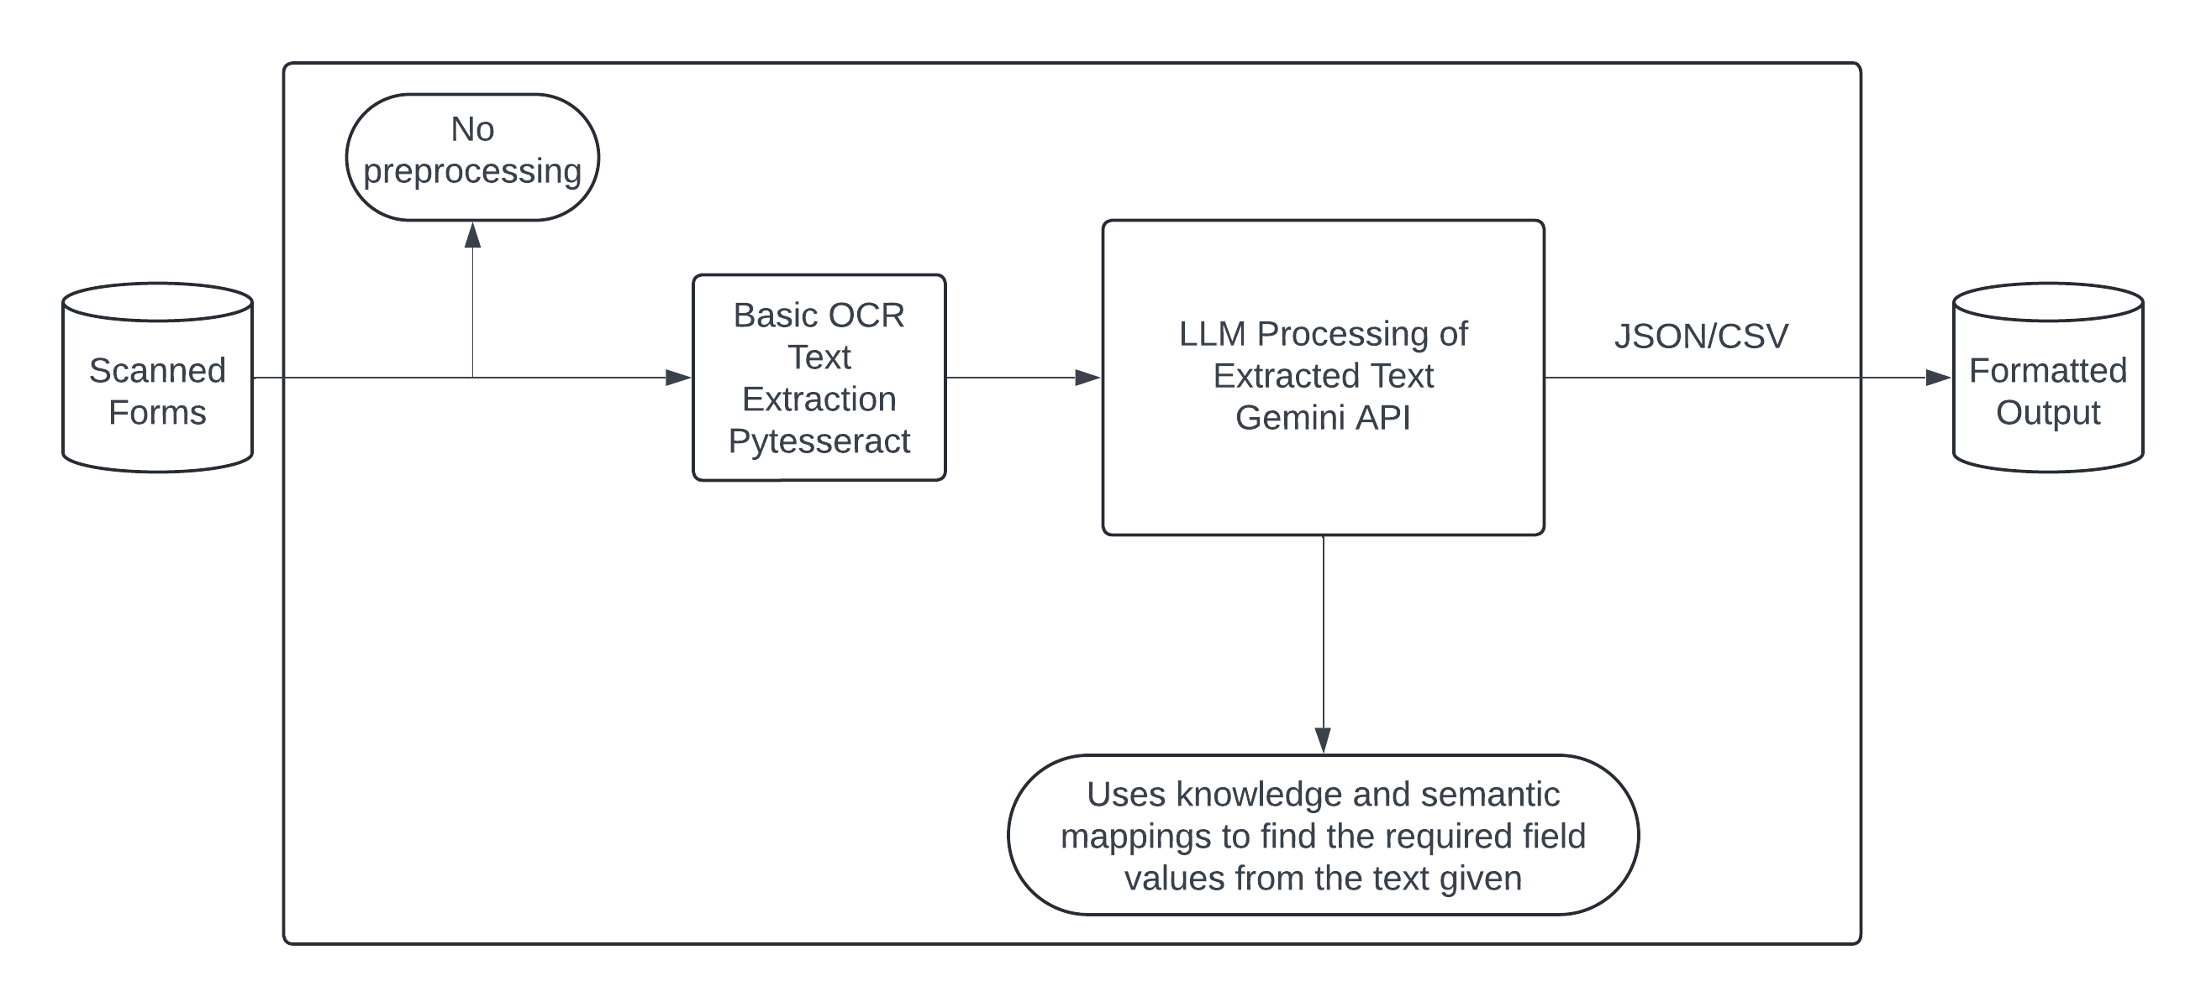

pillow – handling images – supporting different formats
opencv – computer vision programming tools
pytesseract – OCR

Why not to choose this approach?
OCR misinterpretation.
No pre processing.
Directly using LLM produce hallucinated results and no auditability.
No full control.
Less accuracy and security.

